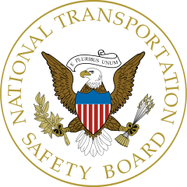

Position Title: Highway Accident Investigator, GS-11/12/13

Position Description

The NTSB is seeking a highly qualified Highway Accident Investigator to join their team. As a Highway Accident Investigator (Vehicle Factors) you will be responsible for organizing, managing and coordinating the investigation of highway transportation accidents and developing and presenting reports with highway transportation safety recommendations for adoption by the Board. You will eventually serve as a Group Chairperson on major highway accidents with an emphasis on Vehicle Factors. You will independently investigate selected regional highway accidents; support and implement the operating plan and mission of the Office of Highway Safety; provide technical assistance in all aspects of vehicle operation, mechanical inspections and compliance with applicable regulations; and review vehicle factors information contained within Office of Highway Safety products and provide substantive comments. You must have professional experience and training that assures a working knowledge of the overall highway transportation system and the role of other government agencies in highway safety administration, planning, regulation and control, particularly in the area of vehicle factors.

Open: February 6, 2015- February 16, 2015

For more information or to apply please visit: https://www.usajobs.gov/JobSearch/Search/GetResults?keyword=ntsb#

